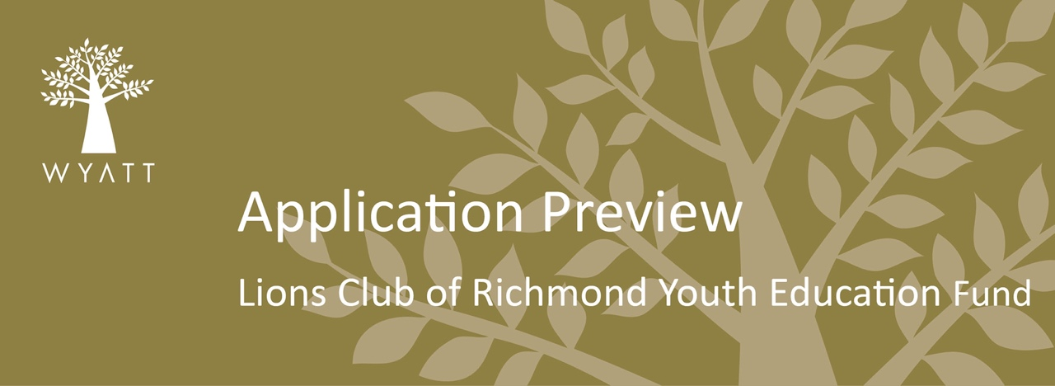

- GET INSPIRATION FROM PAST PROJECTS
- PREVIEW AND PLAN YOUR APPLICATION
- THEN SUBMIT ONLINE: jmp.smartsimple.com.au/welcome/wyatt
- NEW TO WYATT? Follow our step-by-step video to registering your organization is here

Grant Application
Organisation Details

Organisation name:
Organisation type: (uses CLASSIE Version 2.1 Organisation Type classifications) | Human Services, Youth Development, Community Services for Youth

ABN:

Postal address (including state and postcode):

Telephone:

Email :

Web address:

Head of Organisation (CEO or equiv)

(Position Title, Name & email)

What is your organisations history, vision and mission?

Contact Details for this application

Name:

Position:

Telephone:

Email:

Project Details

Project title:

Name of person leading this project [ability to tick as above for project contact details]
Percentage of Aboriginal and Torres Strait Islander people working on the project: | <20%  21-40%  41-60%  61-80%  >80%  Unknown

Does the project lead identify as Aboriginal or Torres Strait Islander?

Brief description of your project:

What are the identified needs that will be addressed by this project?

Are there other organisations providing similar services to the community?

How does this project relate to youth education retention and re-engagement?

How many people are likely to be impacted directly by this project?
In which location are the project beneficiaries located? | [city, state, country]
Which South Australian Local Government Area/s does the project cover?

Is the location of this project considered to be: | Metropolitan Regional  Remote Areas All
Which age groups will most benefit from your Project? (use CLASSIE Version 2.1 Population classifications for age groups) | All  Children and Youth  Adults
What percentage of those benefiting from your project are likely to identify as Aboriginal or Torres Strait Islander? | <20%  21-40%  41-60%  61-80%  >80%  Unknown

Project Details Cont.

Anticipated commencement date of the project:

Anticipated completion date of the project:
Total Project Cost: | $ |  |  | Total Amount Requested: |  | $
Please include a project budget, detailing how the Wyatt funds would be utilised: |  |  |  | The project budget template is available from the Wyatt website
Project Goals/Actions/Outcomes

Wyatt provides resources to respond to the immediate needs of individual and households, and also supports the development of individual skills and capabilities. What barriers to access and opportunity have you identified in this project that will be addressed as a result of funding? Please list a maximum of three.

Are there any other barriers that you believe are in place, that are beyond the scope of being addressed by this project or funding application?

Please provide a minimum of two short term goals that you intend to achieve during the life of the project. Goals should be specific, measurable, attainable, realistic and time-based, and should illustrate how the project will address the barriers identified above

Provide details of up to three Long-Term Outcomes

This is not a mandatory field for applications through the Lions Club of Richmond Youth Education Fund

How do you intend to measure these outcomes? This is not a mandatory field for applications through the Lions Club of Richmond Youth Education Fund
Number of ‘other’ individuals or organisations participating in this project:
(i.e. delivery partners, in-kind support, planning and implementation)

Volunteers: |  |  | Government agencies, departments inc Local Government:
Schools: |  |  | Community organisations:

Referee

Please provide one referee who can speak to your organisation and proposed project

Name

Position

Relationship (if any) to your organisations

Best contact number

Email address

